
Story

Date | 28 October 2026
Team ID | Individual Project
Global Electric Vehicle Market Intelligence Dashboard | Title
Maximum Marks | 5 Marks

By using stories in Tableau, you can effectively communicate complex data in a way that is both interactive and engaging, making it easier for the audience to follow along and understand the insights. It’s a tool for data storytelling, allowing you to present insights in a cohesive, engaging way that takes viewers through a logical progression of findings or analyses.
In Tableau, Story is a feature that allows you to create a sequence of dashboards, visualizations, and text to present data insights in a cohesive and narrative-driven way. It's like a slideshow within Tableau that guides the audience through a series of data points, helping them understand key insights, trends, or outcomes of your analysis.

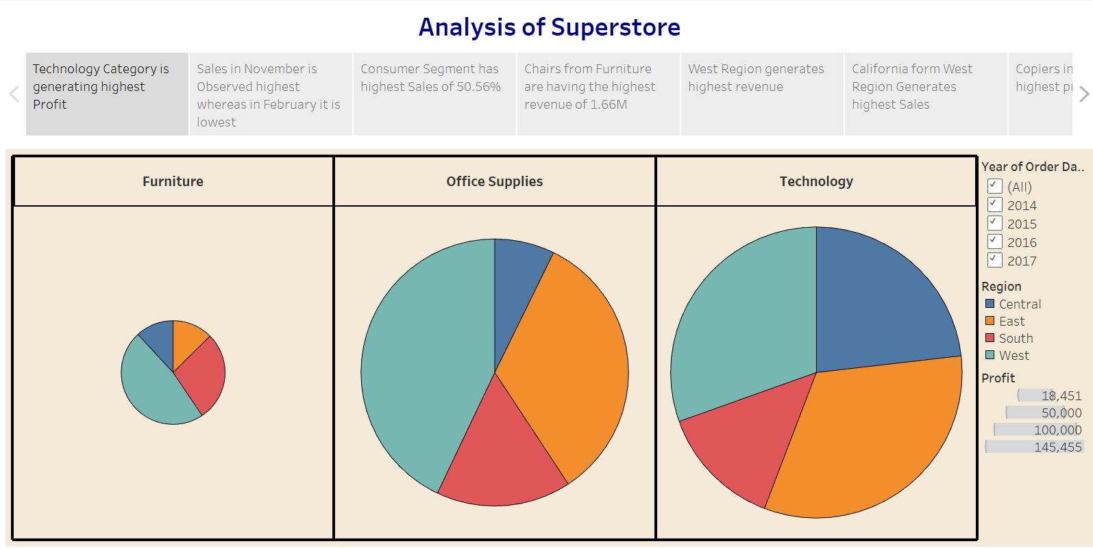

Observations:
- Technology Category Leads in Profit: The Technology category is generating the highest profit among all categories.
- Seasonal Sales Trend: Sales peak in November, while February sees the lowest sales, indicating a possible seasonal trend.
- Consumer Segment Dominates: The Consumer segment contributes to the highest percentage of sales, accounting for 50.56%.
- Top Revenue-Generating Product: Chairs from the Furniture category generate the highest revenue, totaling 1.66M.

Activity 2:
Publish Story on Tableau Public and Paste Public link below
https://public.tableau.com/views/SalesStory_17247663658720/Story1?:language=en-US&:sid=&:redirect=auth&:display_count=n&:origin=viz_share_link

Tableau Story — EV Market Intelligence
Story point 1: Market context — dataset coverage, time period, and available EV categories.
Story point 2: Sales and category trends — annual sales and category contributions based on verified measures.
Story point 3: Competitive landscape — manufacturer ranking and market share where a valid denominator exists.
Story point 4: Battery technology — chemistry mix, capacity, and driving range comparisons.
Story point 5: Geography and customer experience — manufacturing country and ratings, with missingness disclosed.
Story point 6: Decision implications — summarize evidence, caveats, and questions for further analysis.
Activity 2 — Tableau Public story link: not yet available. Add the real URL only after publishing the completed story.
Student: Ansh Shrivastava
Project: Global Electric Vehicle Market Intelligence Dashboard

